DNA Policy
A DNA (Did Not Attend) is when a patient fails to attend a scheduled appointment with any member of the practice team. This includes in-person, telephone and video appointments.

In 2024, the practice had an average of 50 wasted appointments monthly which equates to between 8 and 13 hours of clinical time each month. This clinical time could have been used for other patients in need of our services.

Should you have an appointment scheduled that you no longer require/cannot attend, we ask that you contact the practice via AskmyGP or telephone to cancel or reschedule. You can do this up to two hours before the appointment time which allows time for the appointment to be given to another patient.

If you or someone you care for is experiencing difficulties keeping their appointments, please contact the practice to discuss this. We can work with you to help understand the situation and improve attendance. We understand that there are exceptional circumstances which can lead to non-attendance such as patients who have been admitted to hospital or patients with cognitive conditions such as dementia.

Should a patient not give advanced notice that they no longer require/cannot attend a scheduled appointment, this will be considered as a DNA in your medical record. You will subsequently be sent a DNA letter as follows:

First DNA Letter
You will be sent this letter upon your first recorded DNA. The purpose of this letter is to remind you of the importance of cancelling appointments that you no longer require/cannot attend. This is an informal warning.

Second DNA Letter
You will be sent this letter upon your second recorded DNA. The purpose of this letter is to issue a formal and final warning that, should you DNA further, you will be removed from our practice list. This warning will remain on file for a period 12 months from the date on the letter.

Third DNA Letter
In the event of a third DNA within the 12-month period from the date of the formal and final warning, your case will be reviewed by the GP Partners and you may be removed from the practice list. You will be sent a letter confirming your removal and the practice will notify the health board of the same. You will subsequently be lettered by the health board to inform you of your removal (normally within 14 days).

Additional Information
Repeated DNAs may lead to a breakdown of trust in the professional relationship as the patient has acted in a persistently inconsiderate or unreasonable manner. The practice will give consideration to all potential measures to prevent the breakdown of this professional relationship and subsequent removal of a patient from the practice list. We understand there may be exceptional circumstances where prior warning of non-attendance is not practicable (the examples aforementioned are not exhaustive) and this will be taken into consideration prior to letter issue. Poor organisation/forgetting is not considered such a circumstance.
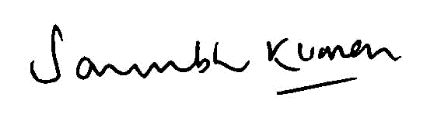
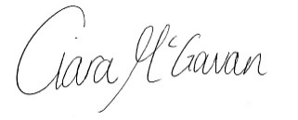
Dr Saurabh Kumar | GP Partner | Ciara McGowan |Practice Manager

