Unacceptable Patient Behaviour Policy
This policy outlines the standards of behaviour expected from patients and visitors to ensure a safe, respectful, and inclusive environment for all staff, patients, and members of the public.

This policy applies to all individuals accessing services, including patients, carers, and visitors, across all premises and communication channels (in person, by phone, email, or online).

Unacceptable Behaviours
The following behaviours are considered unacceptable and will not be tolerated under any circumstances (These are examples only and not an exhaustive list):
- Verbal abuse: shouting, swearing, threatening language, or derogatory remarks.
- Physical aggression: any form of violence, intimidation, or unwanted physical contact.
- Discrimination or harassment: behaviour that targets individuals based on race, gender, sexuality, disability, religion, or any protected characteristic.
- Sexual harassment: inappropriate comments, gestures, or physical actions of a sexual nature.
- Malicious complaints or false accusations: knowingly making unfounded claims against staff or services.
- Damage to property: intentional destruction or misuse of facilities or equipment.
- Persistent disruptive behaviour: repeated refusal to follow reasonable instructions or policies, including appointment attendance and medication adherence.
- Inappropriate use of digital platforms: including abusive messages, defamatory posts, or harassment via email, social media, or online reviews.

Consequences
We take all incidents of unacceptable behaviour seriously. Depending on the severity and frequency of the behaviour, the following actions may be taken:
- Issuance of a formal written warning
- Restriction or conditional access to services (e.g., requiring appointments to be accompanied or held at specific times)
- Immediate removal from the premises
- Reporting to law enforcement or other relevant authorities
- Refusal of non-emergency treatment or services
- Termination of patient registration in extreme cases, in accordance with NHS guidelines and ethical standards

Supporting and Reporting
Our staff are trained to manage challenging interactions with professionalism and compassion. All incidents will be documented, reviewed, and escalated appropriately. Patients and carers are encouraged to raise concerns through our designated feedback channels, and we welcome constructive dialogue aimed at improving care.

We remain committed to treating all individuals with dignity and respect—and expect the same in return.

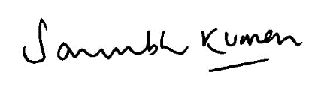
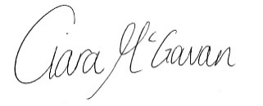
Dr Saurabh Kumar | GP Partner | Ciara McGowan | Practice Manager

